Set up Selenium for Automated Web Testing.

1. Download Selenium (version) from Selenium Website. It’s a jar file. Don’t execute it. Save it into a location. We need to configure this file in the Java IDE like Intellig or Eclipse. Say You saved it inside folder Automation in Desktop.
2. Open Intellij Start a new project for automation (if you are starting or u can use an old project as well). For first time its advised to start a new project. Now inside file -> Project Structure -> Modules -> Dependencies , Add the Selenium file you downloaded and saved. In this case, link it from the Desktop/ Automation folder **NB:** This is project dependent. If you open another project (new or old) it might not have been linked with the SDK of Selenium. Have to do it by yourself for every project.
3. Now, we need to download webdrivers based on the browser you use. It is advised to download all webdrivers for different browsers. Say for Chrome we need Chrome webdriver, for Mozilla we need Mozilla webdriver and so on…Download it and save it inside a folder. Normally C: is used. This is important as we have to link this location inside the java program to run the websites. (We need webdrivers to open and work on web automation iside intellij). (See attached picture to nderstand).
4. Open Intellij / Import necessary classes

org.openqa.selenium.webDriver

org.openqa.selenium.chrome.ChromeDriver

(Here we use these two webdrivers as we are using Chrome browser). The import might vary for other browsers.

In the program we create a WebDriver object and use that object for various operations and testing.

The first program is: This program opens amazon.com in the Chrome Browser

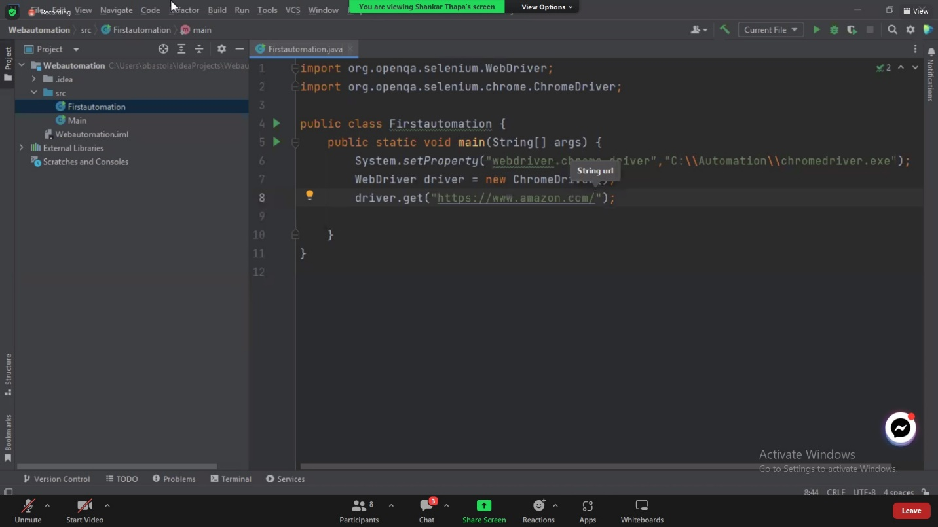

Selenium is used to automate webbrowsers.....

1. download selenuim -> Link inisde Intelegia

2. Download web driver (For chrome) and save it somewhere. Say C://automation

3. import selenium in java class while writing the program

(see FirstAutomation.java for details)

4. Note: We need diffeent web drivers if we are using different browsers. For chrome we use Chrome web driver, For Mozilla we use Mozilla Web Driver and so on......It is called Cross Browser Testing